Project report

Planning of the project: Our aim is to set up our local area network(LAN) and solve the problems during the project.

Overview: There is a trade company which has eighty employees at the moment. There are six departments in this company and there are eighty computers are in use. Now we want to build up a local area network for this company. We hope this local area network meet the following requirements: First of all, this network should have high stability. At the same time, the budget of building up this network is not much so it should be cost-effective. Also, this network should be easily upgraded and expanded in order to adapt the rapid development of this company. It is also important that this network should be easily maintained and fixed.

Virtualization

Virtualization means virtualizing a physical computer into multiple logical computers by using virtualization technology. In our project, we choose VMware for virtualization considering its easy operation and high quality.

There are numerous technologies of virtualization. VMware workstation is one of the most popular platform virtualization software. It supports a lot of requirements of virtualization. Compared with other virtualization platform, it supports to run multiple virtual machines at the same time. Its advanced 3D solutions make it possible to eliminate the degradation of image and video in a virtual machine while running a graphic intensive application. Now, VMware only supports Windows as its host OS and because it is full virtualization technology, each virtual machine runs relatively slowly. (Li, 2010)

Virtualbox is another platform virtualization software. It is similar to VMware which supports to run multiple virtual machines at the same time. (Romero, 2010) Compared with VMware, the speed of running virtual machine on Virtualbox is faster. Another advantage of Virtualbox is it is a totally free open source software. Relative to VMware, Virtualbox supports both Windows and Linux as its host OS. However, Virtualbox has more CPU occupancy and less function than VMware.

KVM is the virtualization feature in the core of Linux. Compared with VMware and Virtualbox, KVM supports only one virtual machine running at the same time which means that if you want to switch to another system you have to initialized the computer. (Varrette, Guzek, Plugaru, Besseron, & Bouvry, 2013)

Domain controller system

Windows server and Ubuntu are two main systems which can be used as server system of domain controller. In this project, we use Windows server 2012 r2 as our server system. Compared with Ubuntu, Windows server has a lot of merits, for example, the technical support of MDSN. In addition, Windows server system is friendly to beginners. All you have to do is operating and maintenance after configuring domain controller on Windows server system while you have to develop all the functions by yourself on Ubuntu system.

Network connection in VMware

There are three choices of network connection in VMware. The first one is **bridged networking**. Under this mode, the virtual machine on VMware can access any machine in local area network. It is necessary to configure IP address and subnet mask manually when you want to communicate with the host machine. At the same time, the IP address of virtual machine should be in the same segment of the network as the host machine. After configuring gateway and DNS address, it is possible for a virtual machine to access to the Internet under bridged networking mode. Another one is **network address translation(NAT)** mode which is mainly used to access to the Internet. Under this mode, it is impossible to access other host machines. Compared with bridged networking mode, it is not necessary to configure IP address, subnet mask and gateway under NAT mode for the reason that it depends on DHCP. Under NAT mode, it is possible for a host machine ping a virtual machine but not the other way around while under bridged networking mode, a host machine and a virtual machine can ping each other. The third one is **host-only** mode. Under this mode, it is not possible for a virtual machine to access to the Internet but to connect to it’s physical computer. (Scott, Rosenblum, Sugerman, & Wang, 2012)

Webserver

Apache and IIS are two most popular webserver software. Apache is more frequently used in Unix or Linux system while IIS can be only used in Microsoft system. IIS configuration is easier than Apache configuration, however, Apache is more stable than IIS. Apache also has good scalability and a wide range of applications for the reason that it is an open source software while IIS is not. However, it is more difficult to operate Apache than IIS. Therefore, IIS is more friendly to novice. (K.Malaiya, 2011)

Project Planning Methodology

We use Scrum as our project methodology.

Diagram 1

Scrum is a methodology of Agile software development. The standard process of Scrum as the Diagram 1 shows. (Schwaber & Sutherland, 2017)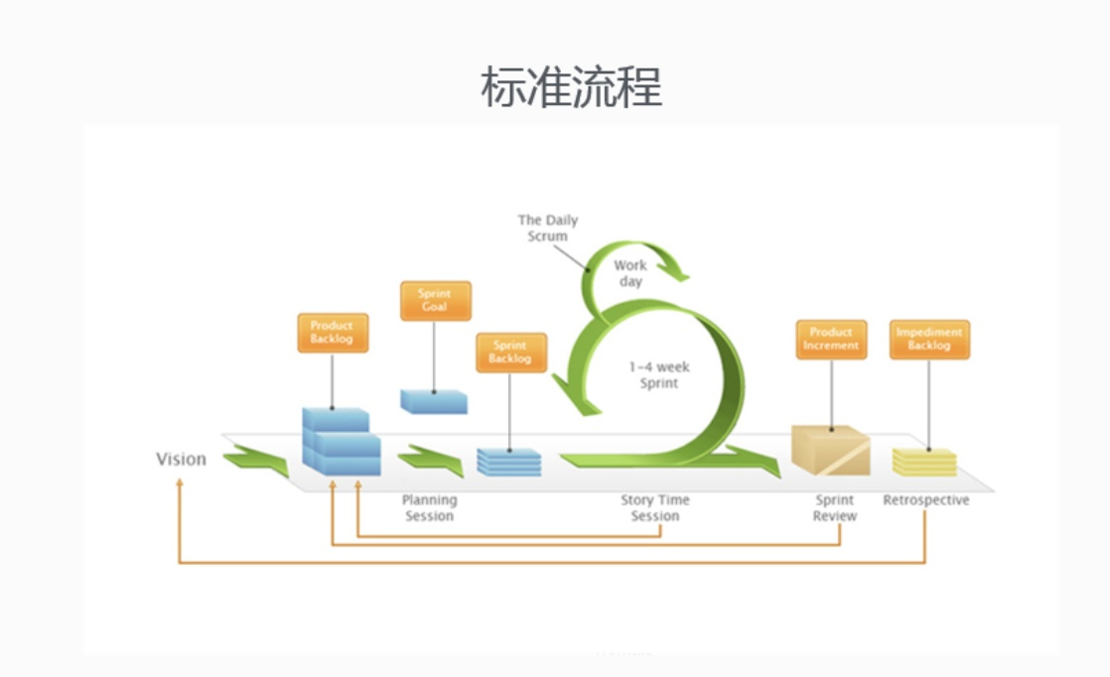

First, we determined product owner, scrum master and development group of our project group. We assume that our tutor is the product owner, Elizabath, Anju and I, we are the development group and I am the scrum master. At the very beginning of this project, we have a sprint planning meeting to give a general planning of our project including what is the goal of our project and assignment of each sprint cycle we should finish during our development cycle.

Our sprint cycle is one to three weeks, the first one is the first week and the assignment of this week is virtualization, the second one is second -forth week and the assignment of this sprint cycle is domain controller configuration. The third one is the fifth week and the assignment is DHCP server and webserver configuration. The fourth one is the sixth week and the assignment is activation of users and groups. The last one is the seventh week and the assignment is proxy configuration and overview of the whole development. Each week during sprint cycle we will have weekly scrum meeting containing three main themes:1.What we did this week 2.What we will do next week 3.What problems we have.

The principles of our meeting are: a. Punctual: 5 minutes late is allowed and no absence is tolerated unless health problem. b. Task collection: encouraging group members to choose task they prefer to do. If no one chooses a task, it will be randomly assigned.

After each sprint cycle, we will have a scrum review inviting our product owner (tutor) to check if we accomplish the assignment of this sprint cycle.

Design:

Diagram 2

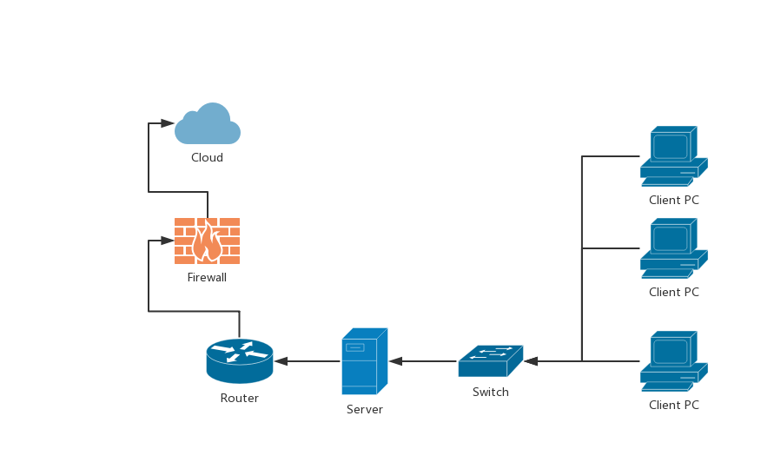

Diagram 3

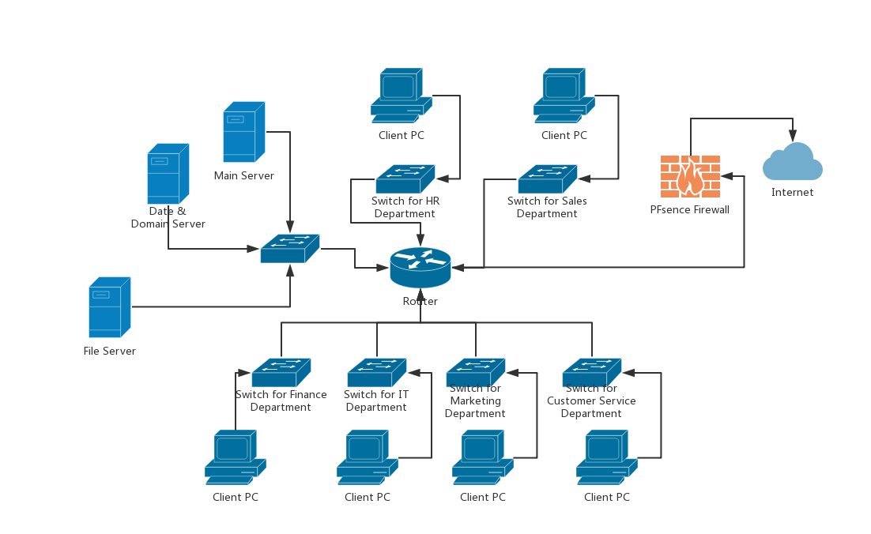

Diagram 2 shows topology structure of our classroom.

Diagram 3 shows topology structure of our scenario.

Requirements of our project:

1. Accomplish integrated management in a domain.
2. Active users and groups, and configuring permission for them.
3. Dynamic management of information.
4. Release information on the Internet.
5. Provide FTP service.

Virtualization

In our project, before building up network for a company, we need to set up environment for simulation first. Therefore, we need to use virtual machine for our simulation. We choose VMware as our virtual machine platform software for it is convenient and easy to use. Then we set up a virtual machine with Windows Server 2012 R2 as our main controller and another virtual machine with Windows 10 as our client pc. The reason we choose Windows Server as our domain controller system is it is used in most company’s networks and it has strong technical support from Microsoft which makes it easy to maintain.

Domain Controller configuration

1. IP address and DNS configuration in windows server. It is necessary for a server to have a static IP address, so we need to configure IP address first before we configure domain controller.

The step of IP address configuration:

1. Set up the server’s name: enter CMD → type sconfig → option 2 → name (CORE1) (ittaster, 2014)
2. Configuring IP address: enter CMD → type sconfig → option 8 → 10 → option 1 → s → IP address → subnet mask → gateway → 2→ preferred DNS (ittaster, 2014)

In our project, our IP address is 192.168.0.101, subnet mask is 255.255.255.0 and default gateway is 192.168.0.1. The first three segment of IP address is decided by subnet mask and the default gateway is decided by IP address. In our simulation, we use domain controller’s IP address as our preferred DNS and the domain controller is also our DNS server. But in a real company, for example, our scenario company, it is useful to have an alternate DNS server.

1. Configuring domain controller

First, we should add AD feature on Windows server manager and set up this server as domain controller.

We follow the step of adding new domain forest on this website: <https://blogs.technet.microsoft.com/canitpro/2013/05/05/step-by-step-adding-a-windows-server-2012-domain-controller-to-an-existing-windows-server-2003-network/> (Bartolo, 2013)

In our project, the name of our domain is ELIZABATH.com

Domain controller is the most important part in a domain. Active Directory is stored on the domain controller which means domain controller contains a database of information such as account, password and computer belonging to this domain. When a computer is connected to the network, the domain controller will identify the account and password of the computer first thus the domain controller is the guard of the domain.

After configuring domain controller, restart the computer and then log in as domain administrator.

Network users and groups

1. Testing DNS resolution

First, using cable to connect domain controller and client pc on switch. Second, using bridged networking of VMware for connection. Last, pinging 192.168.0.101. When it shows reply from the server on the screen then it is successful.

1. DHCP server configuration

We follow steps of configuring DHCP server on this website: <http://www.technig.com/install-configure-dhcp-server-windows-server-2012-r2/> (Shais, 2017)

DHCP server is used for IP address management. (whatismyipaddress.com, n.d.)In our project, we use DHCP server to manage IP address of client pc in our domain. First, we should apply for a series IP address from DHCP server, after getting permission of using these IP address, then the client pc in our domain will get IP address we applied for randomly. It is very convenient for domain configuration by using DHCP server.

1. Adding client pc to domain

We follow steps of adding client pc to a domain on this website: <https://www.integraxor.com/add-client-to-active-directory-domain-part-2/> (IZZUDDIN, 2018)

The account created in a domain can be used to access to any computer of this domain, in another word, it is a shared account.

Domain is a collection of computers with security boundaries, therefore, accessing other machines within the domain does not require permission from other machines.

1. Creating security groups with folder permissions

We follow steps of creating security groups on the following websites: <https://www.youtube.com/watch?v=KnBe1saXLyU> (snippets, 2012)

<https://www.youtube.com/watch?v=WflcPpnUFk0> (mrholverson, 2013)

In our project, we create a sample group of HR department while in our scenario we need to create six groups for each department. By creating different user groups, adding different users to corresponding departments, assigning different permissions to different groups, achieving integrated management in a domain.

Releasing information on the Internet

Webserver configuration

In our project, we use Windows webserver. Adding feature of IIS and FTP server on Windows server manager and then configure sites on Internet Information Service of Windows server. FTP server is used for network sharing service, such as upload, download and browse resource. (nguyen, 2015)

Proxy server

In our project, we use PFsense as our proxy server. It is also called firewall. A firewall is usually built between the Internet and the interface of domain to guarantee domain security. On PFsense, it uses IP blacklist to prevent attack from Internet. (lonston, 2015)

**References**

BartoloAnthony. (2013,May 5). Step-By-Step: Adding a Windows Server 2012 Domain Controller to an Existing Windows Server 2003 network. URL: Microsoft: https://blogs.technet.microsoft.com/canitpro/2013/05/05/step-by-step-adding-a-windows-server-2012-domain-controller-to-an-existing-windows-server-2003-network/

ittaster. (2014,May 20). Server Core Configuration & Management - Windows 2012 R2. URL: youtube: https://www.youtube.com/watch?v=djUWPvQAQZU

IZZUDDIN. (2018,AUGUST 8). STEP-BY-STEP: ADD CLIENT TO ACTIVE DIRECTORY DOMAIN – PART 2. URL: ECAVA IGX: https://www.integraxor.com/add-client-to-active-directory-domain-part-2/

K.MalaiyaH.AlhazmiYashwantSung-WhanWooHyunChulJohOmar.(2011,January). Modeling vulnerability discovery process in Apache and IIS HTTP servers. Computers & Security, page 50-62.

LiPeng. (2010,January). SELECTING AND USING VIRTUALIZATION SOLUTIONS –. CCSC, page 11-17.

lonstonbabin. (2015,January 22). How to Install and Configure pfSense 2.1.5 (Firewall/Router) for Your Home/Office Network. URL: tecmint: https://www.tecmint.com/how-to-install-and-configure-pfsense/

mrholverson. (2013,April 3). Active Directory Users & Groups with Folder Permissions. URL: youtube: https://www.youtube.com/watch?v=WflcPpnUFk0

nguyenphuong. (2015,october 24). How To Install and Configure IIS on Windows Server 2012. URL: youtube: https://www.youtube.com/watch?v=9l388DOSI8Y

Romero, A. V. (2010). *Virtualbox 3.1: Beginner's Guide.* Packt Publishing Ltd.

SchwaberKen, & SutherlandJeff. (2017,November). The Scrum Guide. URL: srum.org: https://www.scrumguides.org/docs/scrumguide/v2017/2017-Scrum-Guide-US.pdf#zoom=100

ScottBugnionEdouard, RosenblumMendelDevine, SugermanJeremy, & WangY.Edward. (2012,november). Bringing Virtualization to the x86 Architecture with the Original VMware Workstation. ACM Transactions on computer systems.

Shais. (2017,March 14). Install And Configure DHCP Server On Windows Server 2012 R2. URL: Teching: http://www.technig.com/install-configure-dhcp-server-windows-server-2012-r2/

snippetslecture. (2012,august 8). Server 2008 Lesson 12 - Creating Security Groups in ActiveDirectory.URL: youtube: https://www.youtube.com/watch?v=KnBe1saXLyU

VarretteSébastien, GuzekMateusz, PlugaruValentin, BesseronXavier, & BouvryPascal. (2013). HPC Performance and Energy-Efficiency of Xen, KVM and VMware Hypervisors. Computer Architecture and High Performance Computing .

whatismyipaddress.com. (n.d.). DHCP: The Networking Protocol That the Gives You an IP Address.URL: whatismyipaddress.com: https://whatismyipaddress.com/dhcp